# Ecommerce Analytics

# Overview

Typically, e-commerce comprises the buying and selling of products and services. Business-to-business, business-to-consumer, or consumer-to-business transactions are all possible. The data utilized in this case study is a free dataset for learning data analytics from a superstore supermarket and was obtained from the Kaggle website. The dataset is sufficiently vast for major global retailers to rely on it to identify the most critical metrics to consider while planning for data analytics in the e-commerce sector.

We are group of 4 members who have worked together on this project to analyze the data and get insights out of it by creating some visual graphs, dashboards and stories.

All the members names are mentioned as follow:

Deval Shaileshkumar Mali, Raman Raj, Akhil Reddy and Akshit Reddy.

The data can be found and confirmed from the following link: <https://www.kaggle.com/datasets/vivek468/superstore-dataset-final>

**Review**

9,994 observations and 21 fields make up the data set. Ship mode, sales, earnings, discounts, State, and quantity are just a few of the attributes. Finding insights from the dataset is the aim. The primary visual representations of what is happening in business are a bar chart, highlighted tables, association matrices, and filled maps.

## **Objectives/Questions**

* Which States have the best sales and profit results?
* What connection exists between the company's quantity sold and it is discount?
* How long do some products often take for delivery after an order is placed?
* Which subcategory performs the best?
* Conducting a market basket study to identify product associations.

**Data visualization and analysis**

1. **State performance**

The dataset offers locations, such as state latitude and longitude, where superstore supermarkets are active. One can identify the finest states where the organization performs successfully using sales and profit metrics. California and New York are the most extraordinary states where the corporation is doing well regarding the products offered. 457,688 and 310,876 worth of items were sold in this area altogether. Sales and profits reported by any business are always positively correlated. According to the statistics, the states with more sales have the most considerable earnings. For instance, California reported 76,381 total earnings, while New York reported 74,039. It is only sometimes the case; for example, a state like Washington generates modest sales yet still makes a profit. It is primarily determined by the items offered in these regions; some are inexpensive but in high demand, while others are expensive but in low demand. When sold, the corporation makes more money (Murray, 2013). All of these statistics are shown in the figure below.

**Figure1: States Performance**

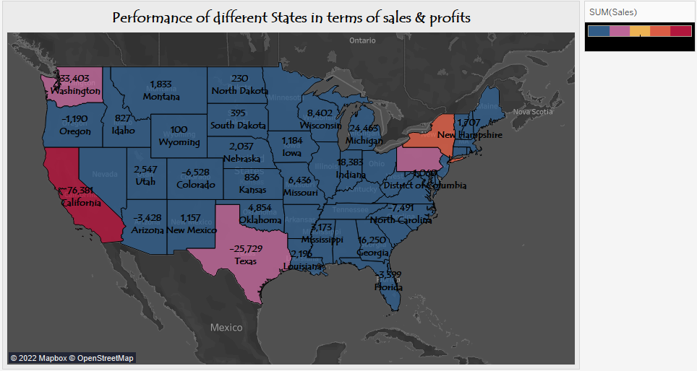

1. **Market Basket Analysis**

One of the retailer's preferred methods of analysis for assisting company directors and owners in comprehending consumer purchasing patterns. Today, one of the main methods used by retailers to find correlations between products is basket analysis. It searches for product combinations that regularly appear together in transactions to carry out its operations. In other words, it lets businesses find links between the goods that customers buy. Papers against binders, furniture, phones, and storage versus binders, are the most vital link. This information is crucial for any e-commerce business since it enables the company to decide which products to the group, how to arrange products in stores, and which products to put on sale (Li, November,2021).

**Figure 2: Market basket analysis**

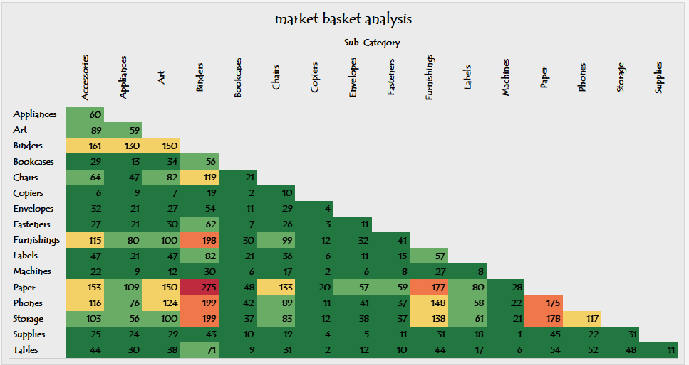

1. **The average time is taken to deliver products from the date of order.**

One of the finest ways to boost sales and profit for the business is to determine how long it typically takes to deliver clients' orders. According to studies, buyers favor businesses that deliver their goods on schedule. From the moment of order until the time of shipment, certain businesses can take a very long time to deliver things. Superstore supermarket typically needs roughly four days from the date of the order to ship out the merchandise. The analysts' objective is to produce this data so the business can identify the most crucial period for the product shipment. The business can increase sales and profits by cutting this period from four to around two or three days according to Izang et al. (2019).

**Figure 3: Average time taken to ship products from the date of order**

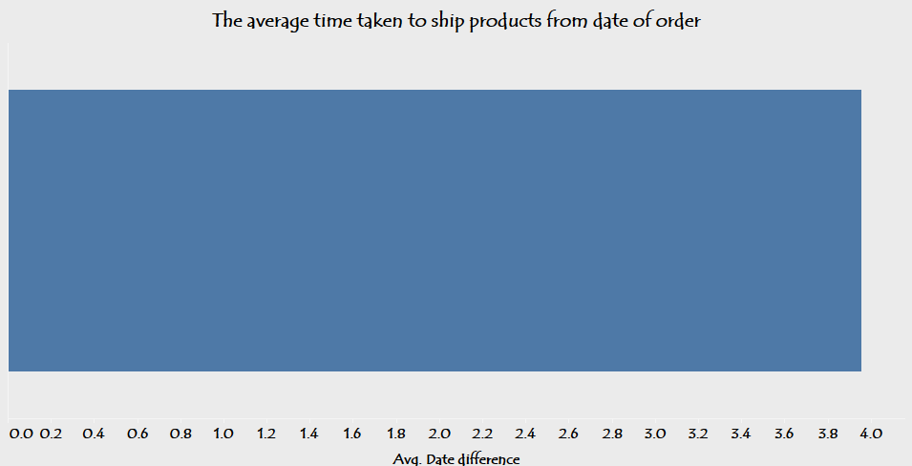

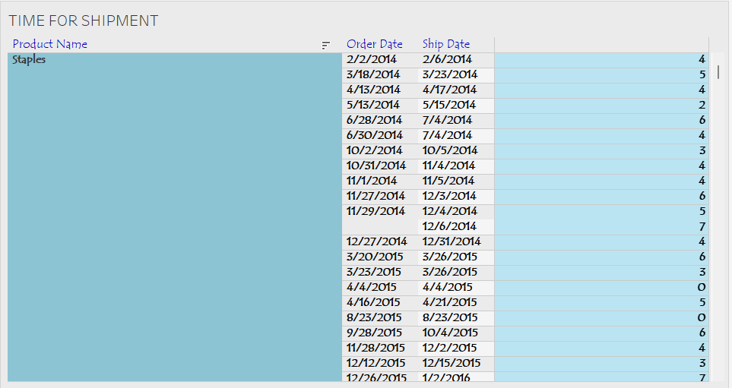

Staples, binders, and accessories are among the items whose shipping times are the longest. The date difference tool in Tableau makes it simple to find this.

1. **What is the relationship between discount and quantity?**

A quantity discount is a financial inducement to entice businesses or people to buy significant commodities. Quantity discounts benefit firms that offer them in addition to helping the seller grow sales income and achieve economies of scale as explained by Arora et al. (2016). The scatterplot below displays what occurs when discount and quantity are combined.

**Figure 4: Discount versus quantity**

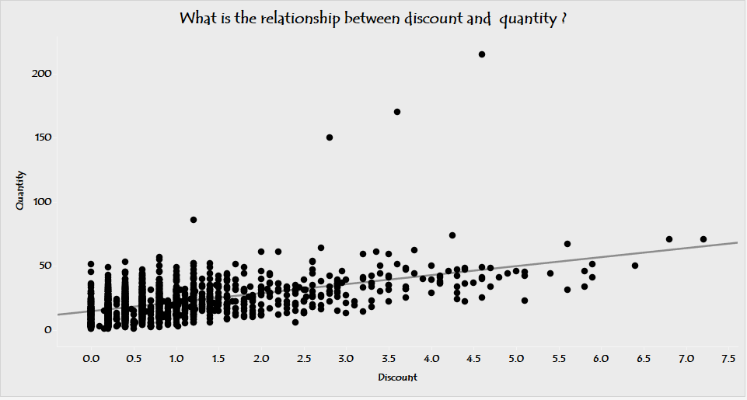

A modest positive link between discount and quantity may be seen in the graph. The more sales are recorded, the bigger the discount rate. The business can significantly advance revenue creation if this methodology is used with market basket analysis.

1. **Profits recorded in a different subcategory**

Copiers have the highest profits of about 55,618, and phones have the lowest earnings of 44,516. Place at the top of the list as the best-performing items. Some products, such as tables, bookcases, and suppliers, still record losses. Tables are the worst product, with a loss of 17,725. These least profitable goods can be discontinued or replaced with others to boost the company's revenue Kumar et at. (2018).

**Figure 5: Subcategories Profits**

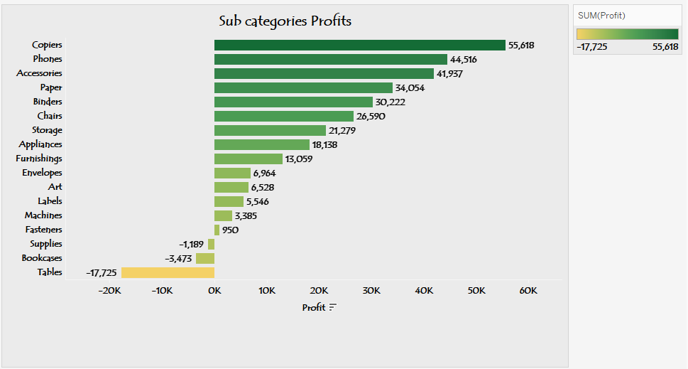

**Conclusion**

Data research and visualization show that the company performs differently in each State. The organization has to set up a system that will boost its output threefold during the months and years. In order to encourage business growth, customer issues like the length of time it takes to receive orders should also be addressed. The company can enhance the amount of data by gathering more variables, including customer information like complaints, which will help the company grow and create new areas to make excellent use of data analytics in this scenario.

**Reference**

Murray, D. G. (2013). *Tableau your data! Fast and easy visual analysis with the tableau software*. John Wiley & Sons.

Li, Y. (2021, November). Application of Tableau in Visual Analysis Data of a US Supermarket Sales. In *2021 International Conference on Signal Processing and Machine Learning (CONF-SPML)* (pp. 190-193). IEEE.

Izang, A. A., Goga, N., Kuyoro, S. O., Alao, O. D., Omotunde, A. A., & Adio, A. K. (2019). Scalable Data Analytics Market Basket Model for Transactional Data Streams. *International Journal of Advanced Computer Science and Applications*, *10*(10).

Kumar, A., Baitule, S. M., & Sahu, S. K. (2018). Data Discovery with Tableau: A Case Study Using Data Analytics Tool. *HELIX*, *8*(5), 3849-3852.

Mahfuza, R., Uddin, R. S., Rahman, Y., & Hai, M. A. (2021, December). A Comprehensive Framework for Superstore Business with Employing Effective Clustering Techniques. In *2021 24th International Conference on Computer and Information Technology (ICCIT)* (pp. 1-6). IEEE.

Arora, M. (2016, May). An Application of Dash Board: A Case of Superstore Sales. In *Monika Arora, Nikhil Pal Singh, Pranav Chhabra (2016), "An Application of Dashboard: A Case of Superstore sales," National Seminar on "TECHNO TRYST*.

**Appendix**

